PROGRAMMING FUNDAMENTALS (CT-175)

FALL FSCS (SECTION “A”)

# PROJECT REPORT

SCEINTIFIC CALCULATOR

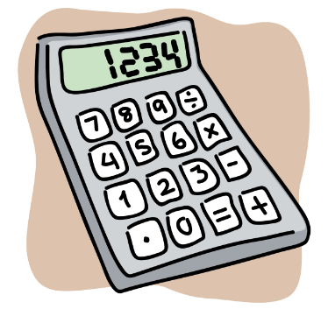

GROUP MEMBERS:

HADIYA KASHIF (CT-008)

ALEESHBA (CT-005)

SARA RAZEEN (CT-049)

BATCH 2022-2026

*DEPARTMENT OF COMPUTER SCIENCE AND INFORMATION TECHNOLOGY*

***PROBLEM STATEMENT:***

To design a scientific calculator using C as programming language in which a user can perform vast mathematical and scientific calculations.

***PROJECT DESCRIPTION:***

Our project covers almost all the programming techniques which we studied in this course. The application allows the user to perform multiple tasks, frequently used calculations and operations of daily life in a user-friendly environment. It can do almost all the things, a scientific calculator can, but except a few. When the program starts, the user can select his or her desired operations and can perform different tasks by providing the data required for that task and can view the result of that operation. Another good thing about our application is that it ends only if the user wants to terminate it so, that he or she can perform many operations at once without running it multiple times.

***DESCRIPTION OF FUNCTIONALITIES:***

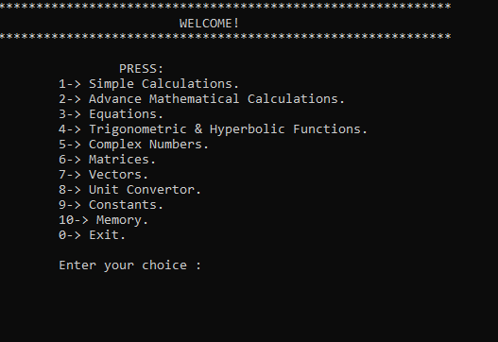

.Main Menu of the calculator

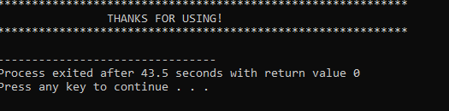

.Exit

The project comprises of following functionalities:

* Simple calculations such as: addition, subtraction, multiplication, division and solving equation based on the aforementioned operations.

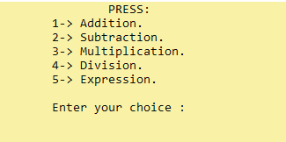

.Case 1(SIMPLE CALCULATIONS)

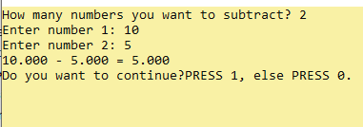

.Addition

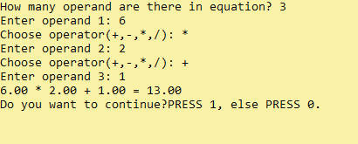

.Expression

* Performing other mathematical operations like finding factorial, power and root of real numbers, permutation and combination, solving exponential function, calculating logarithms of the desired base entered by the user.

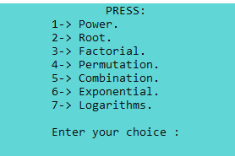

.Case 2(ADVANCE MATHEMATICAL CALCULATIONS)

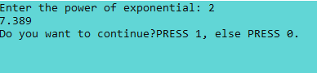

.Exponential function

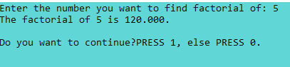

.Factorial Function

* Finding the roots of linear and quadratic equations.

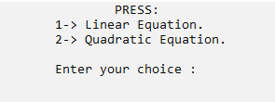

.Case 3(EQUATIONS)

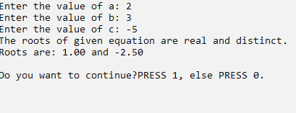

.Solving Quadratic Equations

* Trigonometric and hyperbolic calculations; the calculator contains all the trigonometric and hyperbolic functions along with their inverses.

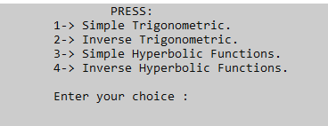

.Case 4 (TRIGONOMETRY)

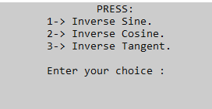

.Inverse Trigonometry

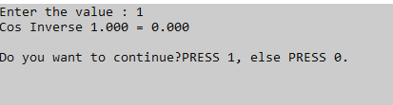

.Inverse Cosine

* Calculations of complex numbers such as addition, subtraction, multiplication, division, modulus and conjugate.

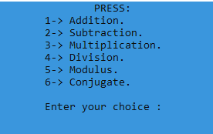

14.Case 5(COMPLEX NUMBER)

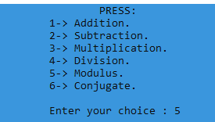

. Options in case 5

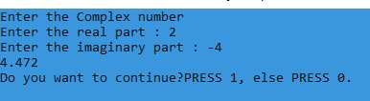

. Modulus operation

* The user can perform simple calculations on matrices and can find the determinant of a matrix.

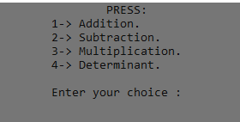

. Case 6(MATRICES)

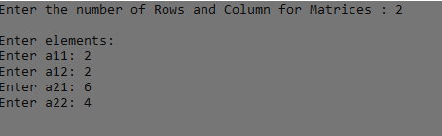

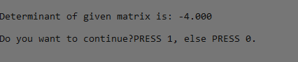

. Determinant of Matrix

* Finding dot and cross product of two vectors and applying addition and subtraction on them.

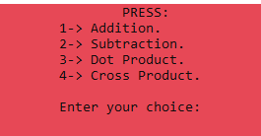

. Case 7(VECTORS)

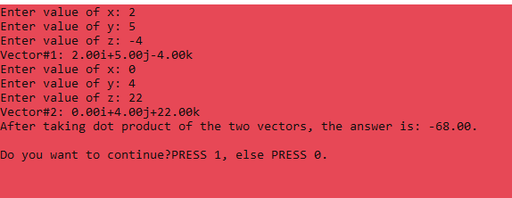

. Dot product of two vectors entered

* It also contain a unit convertor which permits a user to convert the units of mass, distance, temperature and angles into desired unit.

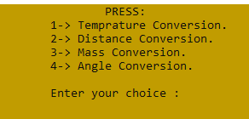

.Case 8(UNIT CONVERSION)

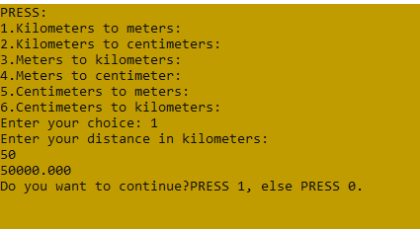

. Conversion of Distance units

* The user can find the values of different constants, which are being used frequently in our daily life.

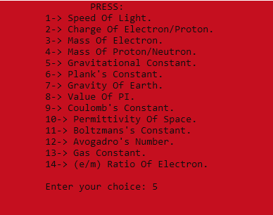

.Case 9(VALUES OF CONSTANTS)

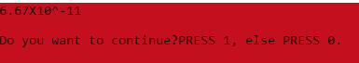

.Value of Gravitational Constant

* The user can view their previously performed operations.

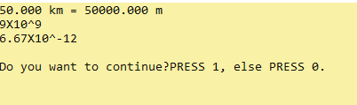

.Case 10(MEMORY)

***PROGRAMMING CONSTRUCTS USED:***

To create this project, we have used almost all of the concepts of C taught to us in this course. To create the main body of the code we used the switch statement which allows the user to choose their desired operation. To create the mathematical operations we used built in and user defined functions, structures, pointers, arrays, strings and iterative structures. File handling is used to create memory option. We have also made header files comprising of closely related calculations, so that our code does not become cluttered and appear clear.

***LIMITATIONS OF THE PROGRAM:***

* The calculator is unable to perform differentiation and integration.
* Equations having highest power till 2 can only be solved.
* The program is unable to perform calculations in any other number system, unlike scientific calculator.

***INIDIVIDUAL CONTRIBUTIONS:***

This project is a result of collective efforts of all members but some of the individual accomplishments are:

1. ALEESHBA (CT-005):

* Main idea of project.
* Created the function for exponential calculations.
* Created the functions for matrices.
* Created the part of complex numbers.
* Created trigonometric functions and their inverses.
* Did the file handling part.

1. HADIYA KASHIF (CT-008):

* Idea for header files.
* Created the function of vectors.
* Created function for solving equations.
* Created function for logarithmic calculations.
* Made functions for advanced simple calculations.
* Responsible for the appearance/outlook of the calculator.

1. SARA RAZEEN (CT-049):

* Created the part of basic calculations.
* Created function for unit conversions.
* Created functions for displaying values of some commonly used constants.
* Project compilation.